**Semester 6 Grammar Exercises**

# Exercise I

**Match the descriptions in column I with their one-word substitutes in column II.**

|  |  |  |
| --- | --- | --- |
| **I** | **Answers** | **II** |
| 1. One who knows many languages | **d** | a. valetudinarian |
| 2. One who dislikes or distrusts women | **g** | B. pessimist |
| 3. One who loves books | **h** | C. altruist |
| 4. One who is doubtful about the existence of God | **f** | d. polyglot |
| 5. A person who doubts accepted opinions | **n** | e. feminist |
| 6. One who is unaffected by joy or grief | **j** | f. agnostic |
| 7. A person who believes that everything is motivated by selfishness | **m** | g. misanthrope |
| 8. A person who expects the worst | **b** | h. bibliophile |

|  |  |  |
| --- | --- | --- |
| 9. One who hates or mistrusts humankind | **g** | i. misogynist |
| 10. A person who supports women’s rights | **e** | j. stoic |
| 11. A person who is overly anxious about his/her health. | **a** | K. hypocrite |
| 12. A person who is selfless and has concern for the welfare of others | **c** | l. maverick |
| 13. A person who is 70-years old | **o** | m. cynic |
| 14. A person of unorthodox or unconventional views | **l** | n. sceptic |
| 15. A person who pretends to be what he/she is not | **k** | o. septuagenerian |

# Exercise II

**Match the descriptions in column I with their one-word substitution in column II.**

|  |  |  |
| --- | --- | --- |
| **I** | **Answers** | **II** |
| 1. Open to more than one possible meaning or interpretation | **e** | a. reticent |
| 2. Script or print that is impossible or hard to read | **g** | b. soporific |

|  |  |  |
| --- | --- | --- |
| 3. Not fit or qualified | **i** | c. fastidious |
| 4. Not speaking freely or openly | **a** | d. congenital |
| 5. Capable of being understood | **h** | e. ambiguous |
| 6. Difficult or impossible to understand | **j** | f. congenial |
| 7. Causing sleep or drowsiness | **b** | g. illegible |
| 8. Excessively attentive at details | **c** | h. intelligible |
| 9. A condition present from birth | **d** | i. ineligible |
| 10. Pleasant and suited to one’s nature | **f** | j. incomprehensible |

# Unit 1 Grammar: Relative Clauses Exercise I

Underline the relative pronouns or adverbs and the nouns they replace.

1. I saw the photographs of **those who** had disappeared without trace.
2. **The friends** with **whom** I sat on graduation day have been my friends for life.
3. **Ordinary people, whose** personal well-being and security are assured, join together in huge numbers to save people they do not know and will never meet.
4. One of the many things I learned at the end of that **Classics corridor** down **which** I ventured at the age of 18.
5. At your age, in spite of a distinct lack of motivation at **university, where** I had spent far too long in the coffee bar writing stories, and far too little time at lectures, I had a knack for passing examinations.
6. I read hastily scribbled letters smuggled out of totalitarian regimes by **men and women who**

were risking imprisonment to inform the outside world of what was happening to them.

1. **This man, whose** life had been shattered by cruelty, took my hand with exquisite courtesy and wished me future happiness.
2. They are my children’s godparents, **the people** to **whom** I’ve been able to turn in times of trouble.
3. I shall never forget the African torture victim, a **young man** no older than I was at the time,

**who** had become mentally ill after he had endured in his homeland.

1. I have one last **hope** for you, **which** is something that I already had at 21.

# Exercise II

## Add who, who(m), whose or which.

1. In the conference, I met a polyglot knew 13 languages. **(who)**
2. He never finds shoes fit him well. **(which)**
3. Why do you always ask questions _ are too complicated? **(which)**
4. People are participating in the competition have to write a story. **(who)**
5. You are exactly the person I wished to see. **(who)**
6. Meet the proud mother _ daughter has won several medals. **(whose)**
7. What did you do with the money I gave you yesterday? **(which)**
8. An atheist is a person does not believe in god. **(who)**
9. I don’t remember the name of the man I spoke to yesterday. **(whom)**
10. Only children parents are illiterate study in this school. **(whose) Exercise III**

## Add who, when, where, or why.

1. Do you know a restaurant we get good samosas? **(where)**
2. A dentist is a person __ is qualified to treat diseases that affect the teeth and gums. **(who)**
3. 1950 is the year India became a republic. **(when)**
4. I still don’t know the reason I was punished. **(why)**
5. Have you seen the artist paintings are extremely thought-provoking? **(whose)**

**Exercise IV**

# Combine the two sentences using who, whose, which/that, where or when.

1. You borrowed a novel from the library. Have you read it?

Ans. Have you read the novel **which** you have borrowed from the library?

1. I met a dancer. He knows you.

Ans. I met a dancer who knows you.

1. We stayed at a hotel. We met an animal rights activist at the hotel.

Ans. We stayed at a hotel **where** we met an animal rights activist.

1. She works in a company. The company’s work ethic is very good.

Ans. She works in a company **where** work ethic is very good.

1. I still remember the day. Our first pet came home that day.

Ans. I still remember the day **when** our first pet came home.

# Exercise V

**Correct the following sentences.**

1. The hill station which we spent our vacation was very beautiful.

Ans. The hill station **where** we spent our vacation was very beautiful.

1. Do you know the name of the river who flows through the city?

Ans. Do you know the name of the river **that/which** flows through the city?

1. The people which work in the stadium are very friendly.

Ans. The people **who** work in the stadium are very friendly.

1. That was the year where severe loses were incurred.

Ans. That was the year **when** severe loses were incurred.

1. A soda maker is a machine who makes soda.

Ans. A soda maker is a machine **which/that** makes soda.

1. Is that the man whose is the author of the bestseller?

Ans. Is that the man **who** is the author of the bestseller?

1. She recommended a book, the title of whom I have forgotten.

Ans. I have forgotten the title of the book **which** she recommended.

1. They are three brothers, all of which are graduates.

Ans. They are three brothers, all of **whom** are graduates.

1. That’s the film where I saw when I was in college.

Ans. That’s the film **which** I saw when I was in college.

1. Is she the one, who mother is a famous dancer.

Ans. Is she the one, **whose** mother is a famous dancer.

# Unit 5 Vocabulary: Formal and Informal Vocabulary Exercise I

**Fill in the blanks with the appropriate word as per the context.**

1. She said to her boss, “My works at a factory.” (dad/**father**)
2. He _ his mobile for any messages. (**checked**/verified)
3. My friend me about this issue. (**told**/informed)
4. The government has ordered the CBI to the case. (look into/**investigate**)
5. “I need your in solving this problem,” said the chairperson to the committeemembers. (help/**assistance**)

# Exercise II

**1. Place the words given below in the appropriate column of the table.**

|  |  |
| --- | --- |
| Formal | Informal |
| purchase | handy |
| commence | guy |
| resume | loo |
| thus | terrific |
| need | reckon |

# Exercise III

**Identify the formal and informal expressions among the following.**

1. I’d be very grateful if you could …. **(Formal)**
2. Amazing! **(Informal)**
3. That’s great, thanks. **(Informal)**
4. He has been monitoring my movement carefully. **(Formal)**
5. Congratulations on your success. **(Formal)**
6. Well done buddy! **(Informal)**
7. You’ve got that wrong. **(Informal)**
8. You must be kidding! **(Informal)**
9. Cool hairstyle! **(Informal)**
10. I think you may be mistaken on this point. **(Formal) Exercise IV**

# Rewrite the following sentences in informal and formal English using appropriate vocabulary.

1. I would like to apologize for forgetting your birthday.

Ans. Sorry! I just forgot your birthday.

1. I request for a laptop.

Ans. I need a laptop.

1. My brother established his business in 2007.

Ans. My brother set up his business in 2007.

1. When did he discover the truth?

Ans. When did he get to know the truth?

1. The price of land has increased manifold.

Ans. The cost of land has risen dramatically.

# Exercise V

**Rewrite the sentence in formal English using appropriate vocabulary.**

1. He got the first rank in the entrance test.

Ans. He secured the first rank in the entrance test.

1. This book is not very cheap.

Ans. This book is expensive.

1. My kids didn’t go to school.

Ans. My children did not go to school.

1. I will get in touch with you.

Ans. I shall contact you.

1. There are lot of parks in the city.

Ans. There are many parks in the city.

# Exercise VI

**Give formal equivalents of the following informal words or expressions.**

|  |  |
| --- | --- |
| 1. In the end: lastly | 6. Let: rent |
| 2. Get in touch: contact | 7. Give up: quit |
| 3. Call on: visit | 8. Death: demise |
| 4. Wrong: incorrect | 9. Chance: opportunity |

|  |  |
| --- | --- |
| 5. Show: clarify | 10. Leave out: exclude |

# Exercise VIII

* 1. **Rewrite the following letter in more appropriate formal English.**

Dear Mr Sharma

We’re really sorry to say that we can’t lend you the sum of five lakh rupees that you need and asked for. But we can perhaps give you a loan for some of the money.

If you are still interested, you can get in touch with our main branch and fix up a meeting with the assistant manager. He will be happy to talk to you about you. Sincerely

**Dear Sir,**

**We regret to inform you that we won’t be able to provide you with the loan of rupees five lakh which you have requested. However, we may be able to provide a loan for some of the funds from our bank. If you are interested, kindly contact our main branch to schedule a meeting with the assistant manager. He would be obliged to speak with you about the said matter.**

**Best Regards,**

**Yours Sincerely, XYZ**

* 1. Rewrite the following text message in informal English.

Dear Mother

I wish to inform you that I will not be able to reach home early this evening. I will be going out for dinner with my friends. I request you not to wait for me. Moreover, please finish your dinner and go to sleep. I have my set of keys with me. Good night.

**Dear Mummy,**

**I am going out with my friends, and may return home late this evening. Please don’t wait for me, you may have your dinner and sleep. I have the other pair of keys with me.**

**Good Night**

# GRAMMAR : SENTENCE TYPES

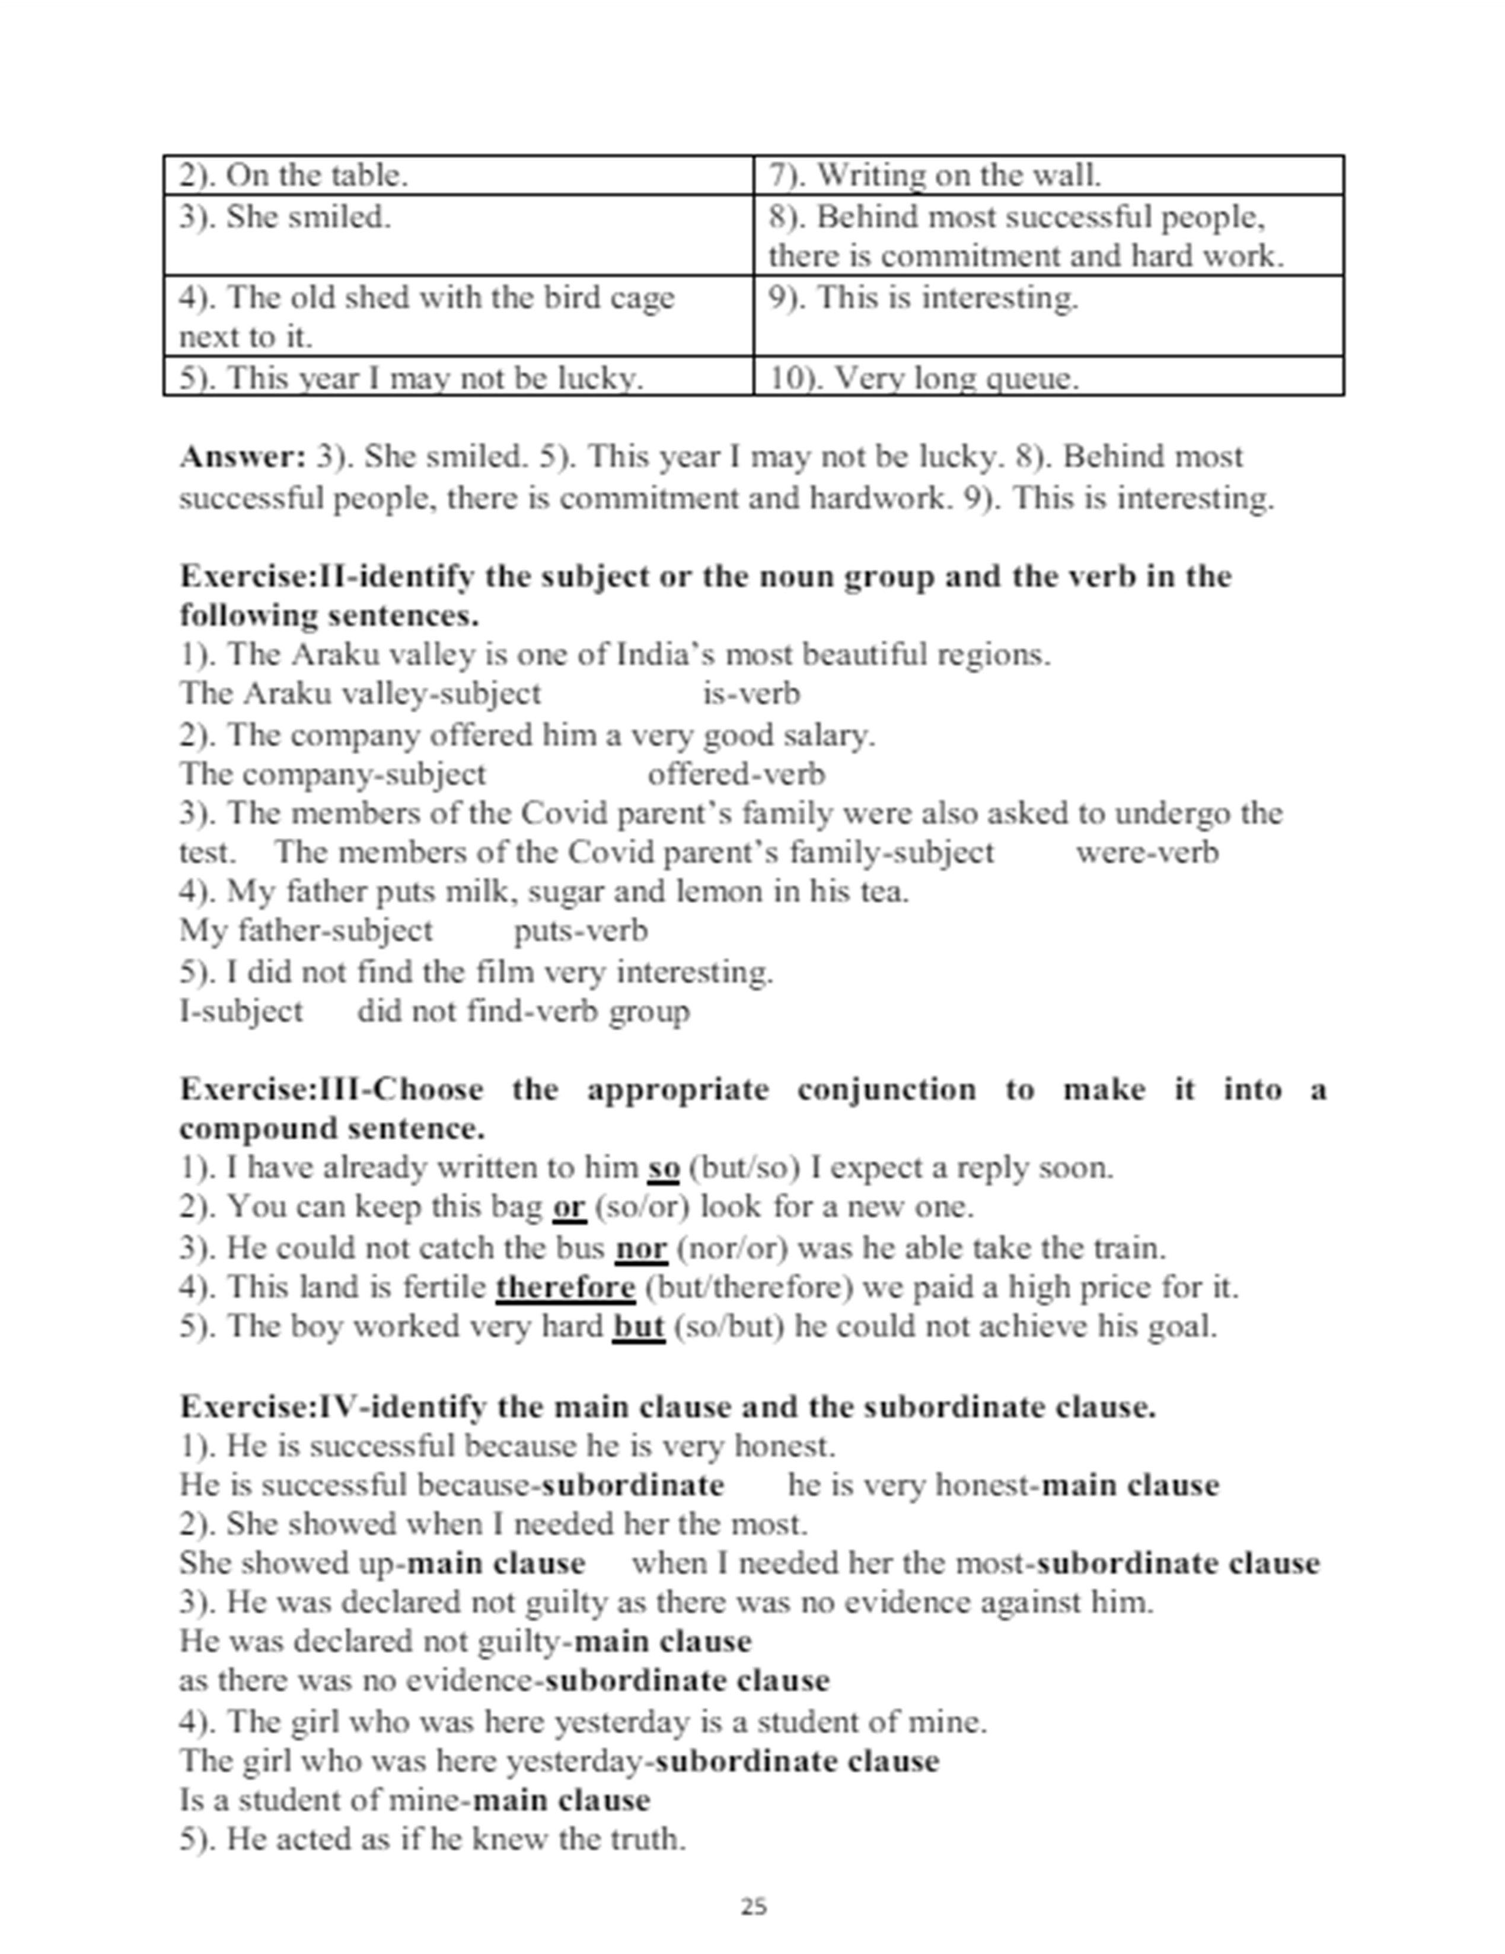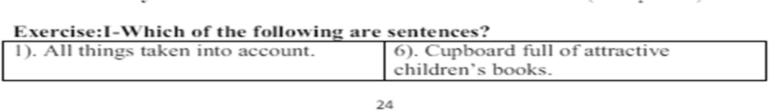

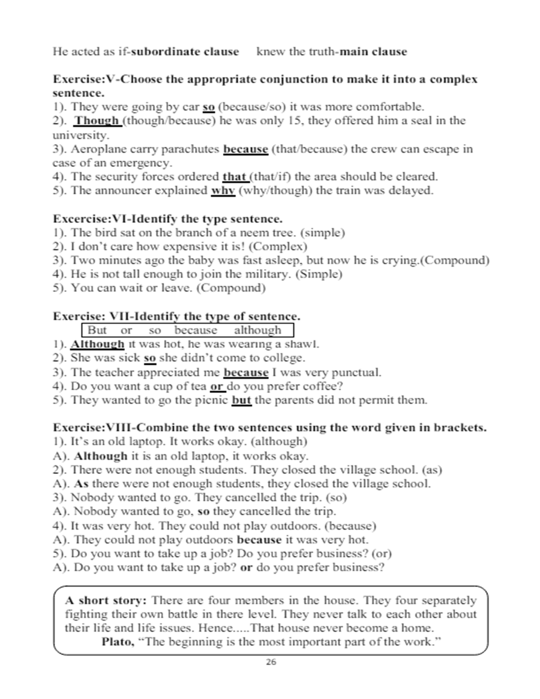

**UNIT 6**

**Curriculum Vitae**

# Resume Sample For Freshers, Freshmen, and Students

Resume writing is a complicated task that requires a lot of time and effort.

In order to get a job interview and employment afterward, you should create a resume that is based on modern resume writing trends.

Employers like to see short and relevant resumes. That said, the ideal length for a resume is one page.

Here are a few tips to help you write a great resume.

Resume Writing Tips

* 1. Use Short Bullet Points
  2. Add Your Internships and Projects
  3. Emphasize your Skills and Knowledge
  4. Customize to the Needs of the Employer

1. Use Short Bullet Points

The key to writing an effective resume is shortness. Use short bullet phrases and tables where necessary.

1. Add Your Internships and Projects

Employers look for your real-life experiences such as internships, as well as projects. Make sure you include this information in your resume.

1. Emphasize your Skills and Knowledge

In your resume, make different sections of your relevant soft and hard skills. Mention your computer skills also.

1. Customize to the Needs of the Employer

It is imperative to match the employer’s needs. Assess their exact requirements and expectations and address the same in your resume.

The following is a resume sample for a BBA student or a new graduate who has recently done his BBA.

New Graduate Resume / CV Sample For Freshers

# Anna Anderson

35 Victoria Street, Vaughan, ON S9D 3C9 (000) 965-3021

anna @ email.com

# CAREER OBJECTIVE

To make a positive contribution as part of a dynamic and well-reputed organization. Bringing sound business acumen coupled with strong technical, management, decision making, and communication skills.

# EDUCATION

Course – 2021

University of Ontario Institute of Technology, Oshawa, ON Major: Finance

Minor: Banking GPA: 3.41

# INTERNSHIP EXPERIENCES

* Citi Bank (Telemarketing)
* HSBC (Financial Services)
* Sales Manager: Arete Trading Company (online job)
* E-marketing AAA Company (online job UK project)

# CORE SKILLS & ABILITIES

* Capable of working in a bilingual environment
* Ambitious, hardworking, energetic and well disciplined
* Able to meet deadlines and handle responsibilities
* Positive thinking, self-motivated and flexible
* Soft-spoken with good communication skills

# FINANCIAL PROJECTS

* Financial Analysis of Toyota Motors
* Performance of mutual funds (RBC)
* Seasonality in funds performance
* Risk and Return Analysis
* Dividend policies

# COMPUTER EXPERTISE

* Sound Knowledge of Ms-Word, Excel, and PowerPoint
* Good Typewriting speed (45w/pm)
* Well experienced in using the internet
* Able to learn new software applications What Is a Curriculum Vitae?

A **curriculum vitae** (CV) provides a summary of your experience and skills. Typically, CVs for entry-level candidates are longer than resumes—at least two or three pages. CVs for mid-level candidates who have amassed numerous publications tend to run much longer.

CVs include extensive information on your academic background, including teaching experience, degrees, research, awards, publications, presentations, and other achievements.

CVs are lengthier than resumes and include more information, particularly details related to one’s academic and research background.2

A **curriculum vitae summary** is a one-to-two-page, condensed version of a full curriculum vitae. A CV summary is a way to quickly and concisely convey one’s skills and qualifications. Sometimes large organizations will initially ask for a one-page CV summary when they expect a large pool of applicants.

What to Include in Your Curriculum Vitae

Your curriculum vitae should include your name, contact information, education, skills, and experience.

In addition to the basics, a CV includes research and teaching experience, publications, grants and fellowships, professional associations and licenses, awards, and other information relevant to the position you are applying for.

**CV samples and formats for Freshers** UYIO

Contact no. - 90******

Email – xy*****@yahoo.com

# Objective

To make a positive contribution as part of your dynamic and well reputed organization in a position where my management, decision making and communication skills will be appreciated and enhanced.

# Personal Abilities

-Ambitious, hard working, energetic and well disciplined.

-Positive thinking, self-motivated and flexible

-Good communication skills

-Soft spoken

-Good oral and written skills

# Education

-BBA Hons, Major finance 1st Division from MNO University

-HSC from A university with 1st grade

# Academic project

-Analysis of Financial Statement of POI

-Performance of mutual funds

-Seasonality in funds performance

-Risk and Return Analysis

-Dividend policies

# COMPUTER SKILLS

-Sound Knowledge of Ms-Word, Ms- Excel, Ms-Power Point Good Typewriting speed (50w/pm)

-Well experienced with use of internet

# Extra Curricular Activities

* Participated in inter- college competitions
* Participated in organizing cultural even in ASB
* Member of event organizing committee

# Personal Details

-Date of Birth :xx/xx/xxxx

-Languages :English, Hindi, Marathi

-Hobbies : Dancing, Playing Cricket

-Address : Ufro, 78 plot, Wopi, XXXXX Entry Level Cover Letter Writing Tips

Now the primary challenge is to build a resume and cover letter, which is ready to excel in the current job market?

These two documents are essential marketing tools to get your very first job. It is strongly recommended to submit a cover letter (even if it is not required by the employer) with your resume and the rest of your application materials.

How to Write a Successful CV

Know what to include and how to format the information. These sample CVs provide a helpful guide; this piece offers tips for writing your very first CV.

Choose an appropriate format. Make sure you choose a curriculum vitae format that is appropriate for the position you are applying for. If you are applying for a fellowship, for example, you won't need to include the personal information that may be included in an international CV.

U.S. vs. International CVs

While CVs in the U.S. are used primarily when applying for academic, education, scientific, medical, or research positions or when applying for fellowships or grants, candidates for international jobs may be required to submit “CVs” for almost any type of job they apply for.

International CVs

In Europe, the Middle East, Africa, or Asia, employers may expect to receive a “curriculum vitae” (often with an attached photograph) rather than a resume. However, international “CVs” are structured and formatted more like a resume than they are an academic U.S. curriculum vitae.5

The Difference Between U.S. and International CVs

The primary difference between a U.S. resume and an international CV is that employers in other countries, unfettered by U.S. employment discrimination laws, require more personal information than one would provide on a resume in the United States

These details vary by country, but can include one’s date of birth, nationality, marital status, and number of children. Here’s how to structure your international curriculum vitae.

A cover letter gives you a chance to emphasize your capabilities and most relevant skills and experiences gained through your education, training, and summer jobs.

The first thing to remember about entry level cover letter writing is to keep it brief – usually no more than a single page.

Because hiring managers do not have time to read every cover letter and job application they receive, so they skim cover letters for required keywords and information.

The following tips will guide you on how to write an entry level cover letter to apply for an advertised job.

* State your desire to work for the employer; why the company’s core values and mission hasattracted you, and how can you contribute to its purpose? Demonstrate that you have sufficient information about the company and its business.



* Mention a particular job title as it is printed in the ad, and the company’s name as well.

Entry Level Cover Letter Writing Tips

* Point out your major skills, abilities, and strengths that make you an excellent applicant for thejob.
* Use your cover letter to support your resume and job application.
* Expand the major points of your resume in your cover letter.
* Relate your capabilities with the requirements of the employer.
* Ensure that your cover letter shows how you meet the exact criteria for the job.
* Mention your enthusiasm, strengths, internships, summer experiences, and educational results.
* Make sure your cover letter is written in a way which concentrates on each of the main skillsand requirements of the employer.
* List your most important selling points in bullet form to formulate them easy to understand.
* A personal touch will make you stand out from the rest.
* Precisely explain why you think you will be a great fit, how much you like the company’sproducts and services, or the concern you have in the area the business works in.
* Ask for a personal meeting or interview in the last paragraph of your letter – this will show thatyou can take the initiative and are keen to get the job.

# Vocabulary: Appropriacy Exercise I

**Identify the formal and informal ways of greeting among the following.**

|  |  |
| --- | --- |
| 1. How are you? (Formal) | 6. What’s up? (Informal) |
| 2. Good to see you. (Informal) | 7. How’s it going? (Informal) |
| 3. How are things? (Informal) | 8. How is life? (Informal) |
| 4. How are you doing? (Informal) | 9. How have you been keeping? (Formal) |
| 5. How is everything? (Formal) | 10. I trust that everything is well. (Formal) |

# Exercise II

**Rewrite the following sentences in formal/informal English.**

|  |  |
| --- | --- |
| 1. Hi there! | Hello! (Formal) |
| 2. See you later! | Bye! (informal) |

|  |  |
| --- | --- |
| 3. I would like to apologize for forgetting your birthday. | Sorry! I forgot your birthday (Informal) |
| 4. Thanks a lot for the present! | Thank You for the present (Formal) |
| 5. How do you do, Mrs. Rao? | How is it going? (Informal) |
| 6. It is a pleasure to meet you. | Good to see you (Informal) |
| 7. Call me later. | Call back (Informal) |
| 8. I just want to express my sincere thanks for all you have done for us. | Thanks for helping (Informa) |
| 9. I’m afraid you're mistaken | Sorry! You’re wrong (Informal) |
| 10. More tea? | Would you like to have some more tea? (Formal) |

# Exercise III

**Give gender-fair or gender-neutral alternatives to the following words, phrases and usages.**

|  |  |
| --- | --- |
| 1. Miss/Mrs | Ms. |
| 2. Actress | Actor |
| 3. Salesman/Salesgirl/Salesboy | Salesperson |
| 4. Poetess | Poet |
| 5. Common man | Common person |

|  |  |
| --- | --- |
| 6. Man-made | Artificial |
| 7. The best man for the job | The best candidate for the job |
| 8. May the best man win! | May the best person win! |
| 9. Mankind | Humanity |
| 10. Man of the match | Player of the match |

# Exercise IV

**Rewrite the following sentences to make them more inclusive.**

1. Give the student his scholarship right away.

# Ans. Give the student their scholarship.

1. As a teacher, he faces excessive paperwork daily.

# Ans. As a teacher, they face excessive paperwork daily.

1. Each student should submit his assignment before the last date.

# Ans. Each student should submit their assignment before the last date.

1. It is the duty of every driver to carry his driver’s license at all time.

# Ans. It is the duty of every driver to carry his driver’s license at all times.

1. When a person watches too much television, his brain turns to mush.

Ans. When a person watches too much television, their brain turns to mush.

1. If an employee has a problem with a supervisor, he should discuss the problem with theofficer.

Ans. If an employee has a problem with a supervisor, they should discuss the problem with the officer.

1. The average student is worried about his grades.

Ans. The average student is worried about their grades.

1. Does everybody have his book?

Ans. Does everybody have their book?

1. When the student hands in his paper, assess it immediately.

Ans. When the student hands in their paper, assess it immediately.

1. A law-abiding citizen pays his taxes promptly.

# Grammar: Common Errors Exercise I

**Correct the following sentences.**

|  |  |
| --- | --- |
| 1. The chair is made of the wood. | **The chair is made of wood.** |
| 2. He always eats piece of chocolate after lunch. | **He always eats bar of chocolate after lunch** |
| 3. She told me the interesting story. | **She told me an interesting story.** |
| 4. He has the good idea about the matter. | **He knows the matter very well.** |
| 5. I saw him in the yellow car. | **I saw him in a yellow car.** |

|  |  |
| --- | --- |
| 6. People consider him as a great leader. | **People consider him a great leader.** |
| 7. I agree with your proposal. | **I agree with your proposal.** |
| 8. They started to Karimnagar. | **They left for Karimnagar.** |
| 9. They will return in this month. | **They will return this month.** |
| 10. I suffer with short-sightedness. | **I suffer from short-sightedness.** |

# Exercise II

**Correct the following sentences.**

|  |  |
| --- | --- |
| 1. The police will cancel your driving license if you will break the rules again. | **The police will cancel your driving license if you break the rules again.** |
| 2. It is time they start. | **It is time they should start.** |
| 3. He lives in Delhi for five years. | **He has been living in Delhi for five years.** |
| 4. If I had known of your arrival, I would meet you. | **If known of your arrival, I would meet you** |
| 5. He was late so he is scolded by the teacher. | **He was scolded by the teacher for being late.** |

|  |  |
| --- | --- |
| 6. The teacher is taking two classes daily. | **The teacher takes two classes daily.** |
| 7. I am having a headache. | **I have a headache.** |
| 8. When she sings, you can’t help to listen to her. | **When she sings, you can’t help listening to her.** |
| 9. He wants that I should do the work. | **He wants me to do the work.** |
| 10. The students and the teacher is in the class. | **The students and the teacher are in the class.** |

# Exercise III

**Correct the following sentences.**

|  |  |
| --- | --- |
| 1. You need to tell me again. | **1. You need not tell me again.** |
| 2. They disposed off the junk. | **2. They disposed of all the junk.** |
| 3. He is trying hard to cope up with the situation. | **3. He is trying hard to cope with the situation.** |
| 4. Did you ever read The Jungle Book? | **4. Have you ever read The Jungle Book?** |
| 5. According to me, it’s true. | **5. According to me, it is true.** |
| 6. If I will be late, I’ll call you. | **6. If I am late, I’ll call you.** |
| 7. She tried to quickly finish the book before she had to leave. | **7. She tried to quickly finish the book before she could leave.** |

|  |  |
| --- | --- |
| 8. While walking in the garden, he found a sparkling woman’s bracelet. | **8. While walking in the garden, he found a sparkling bracelet of a woman.** |
| 9. Please reply back immediately. | **9. Please reply immediately.** |
| 10. Being a hot day, the old man did not go out. | **10. It being a very hot day, the old man did not go out.** |